**CSE3501-Information security analysis and audit**

Name: O G RAGAVI

Reg No: 20BCE1988

Lab Ex: 8

Title: Tools, Setoolkit, the harvester lazybox

**Pre-requisite:**

Find your ip address using <http://whatismyipaddress.com/>

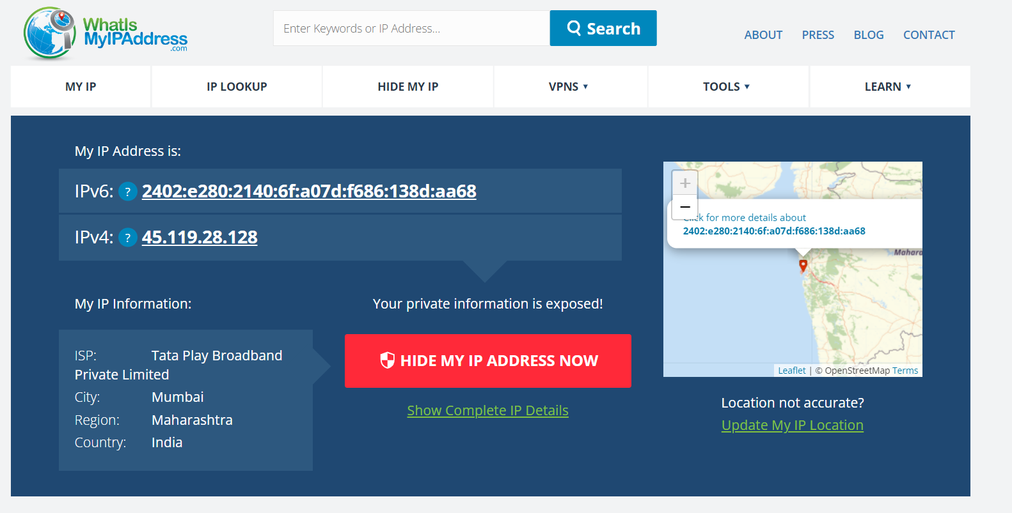

**Step1:** Open kali linux terminal and type the following command

**git clone** [**https://github.com/trustedsec/social-engineer-toolkit**](https://github.com/trustedsec/social-engineer-toolkit)

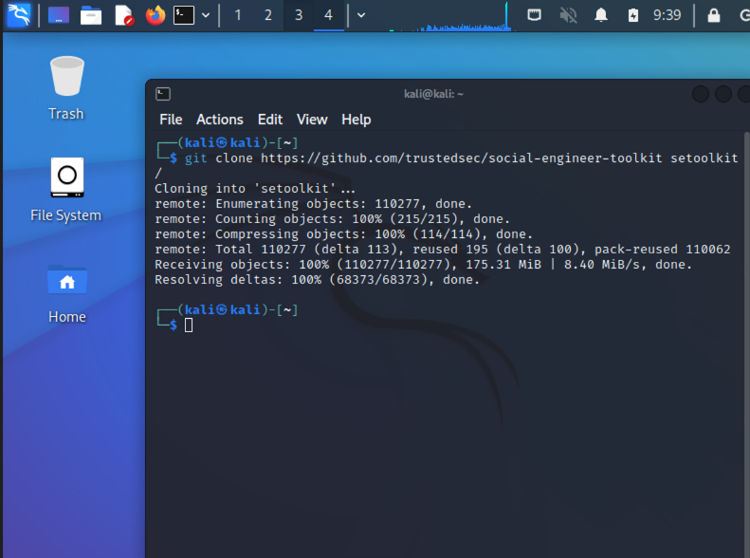

**cd toolkit**



**pip3 install -r requirements.txt**

**python setup.py**

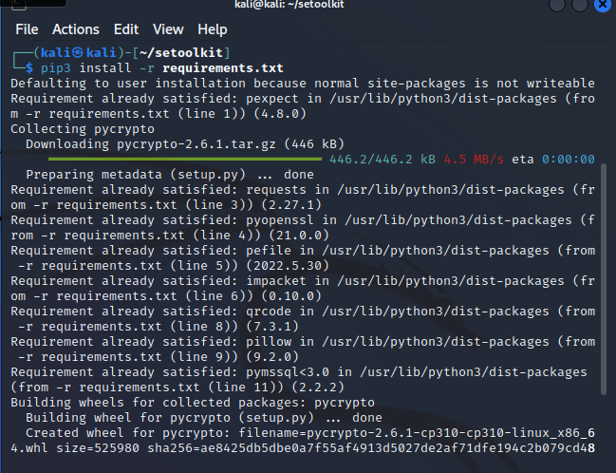

**sudo setoolkit**

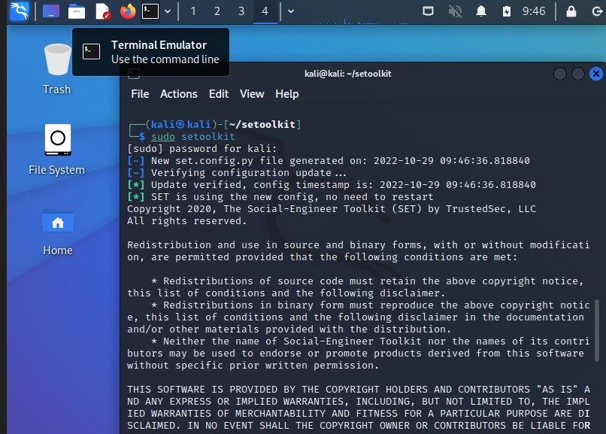

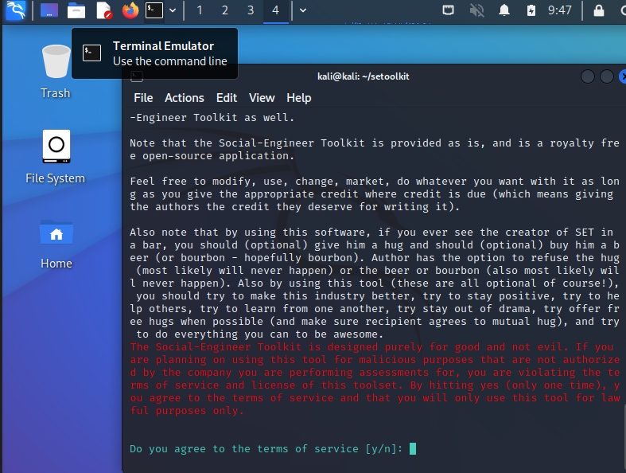

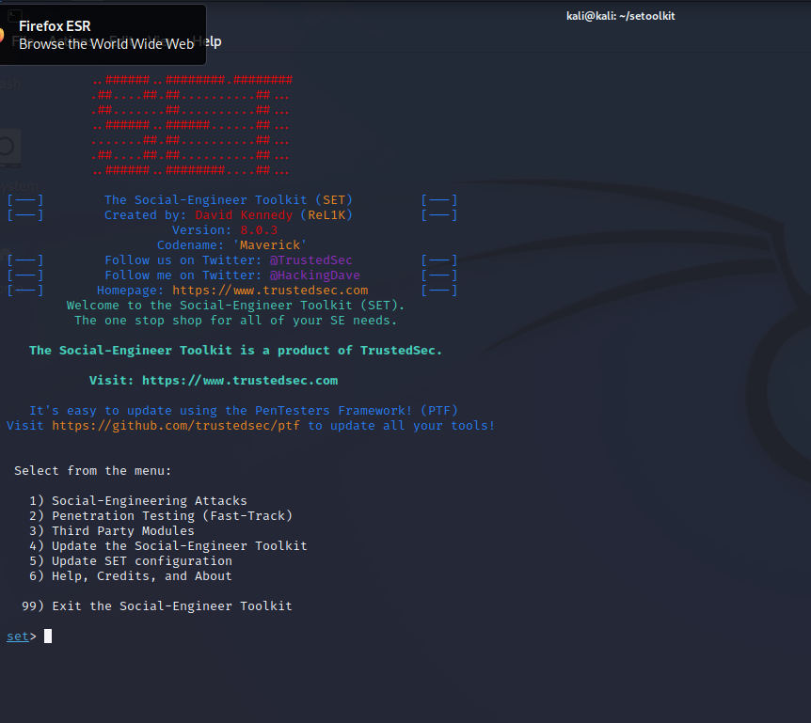

**Step2: choose 1(Social engineering attack)**

**Choose 2(web attack)**

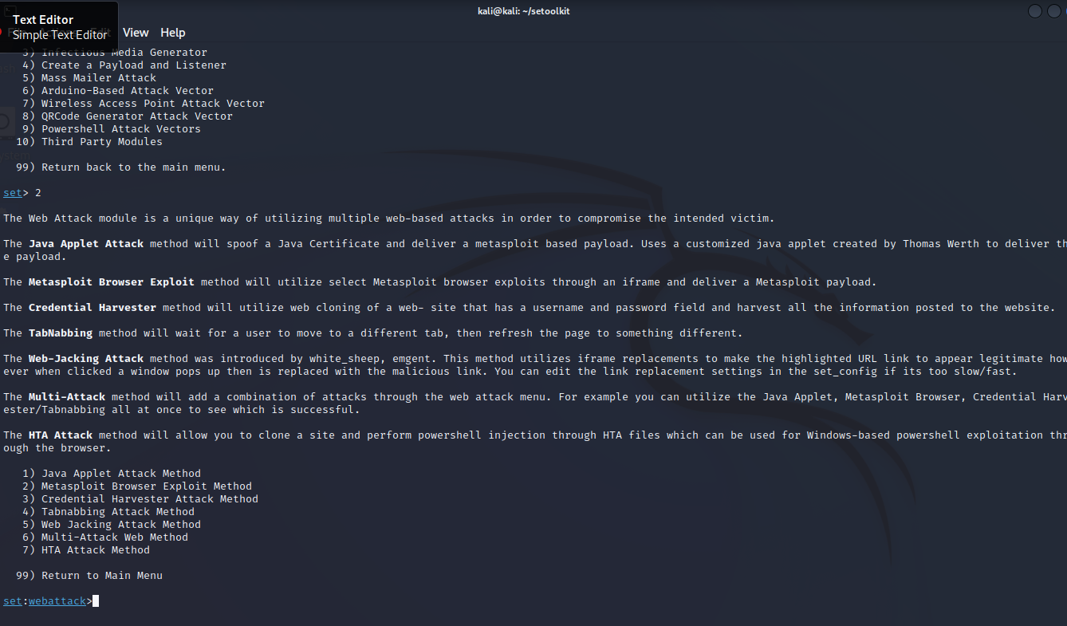

**Choose 3( credential harvester attack method)**

**Choose 1 ( web templates)**

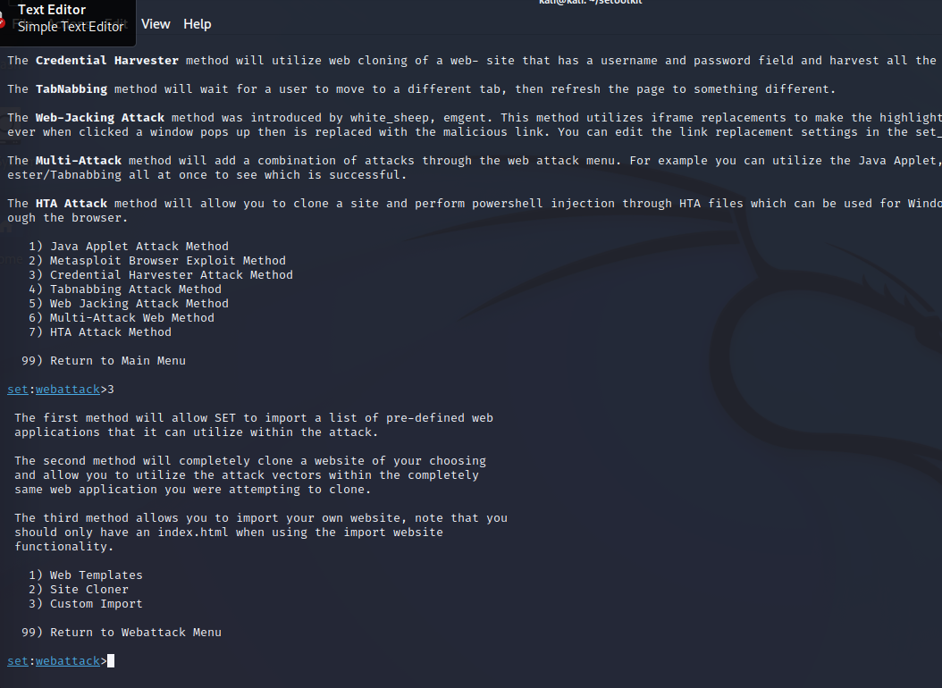

**Step 3: Open another terminal and find the ip address of the kali.**

**Type command ifconfig.**

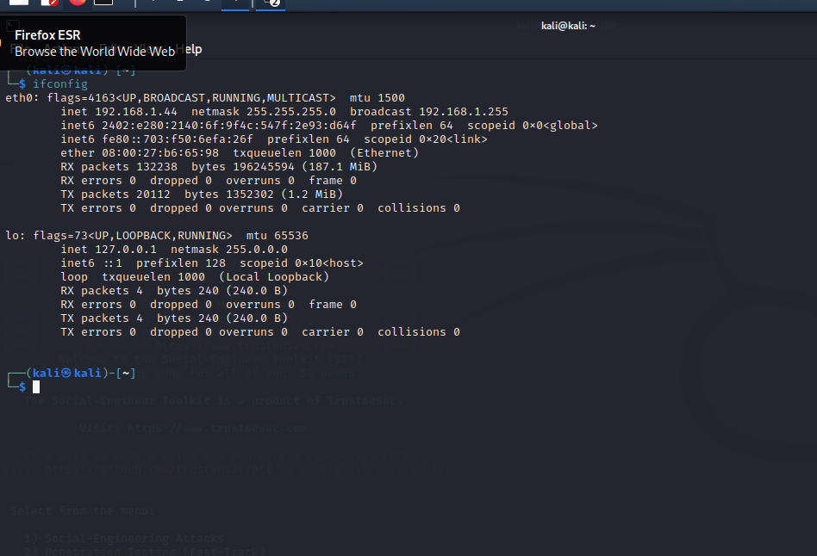

**Step 4: Now go to the previous terminal and type the ip address of kali .**

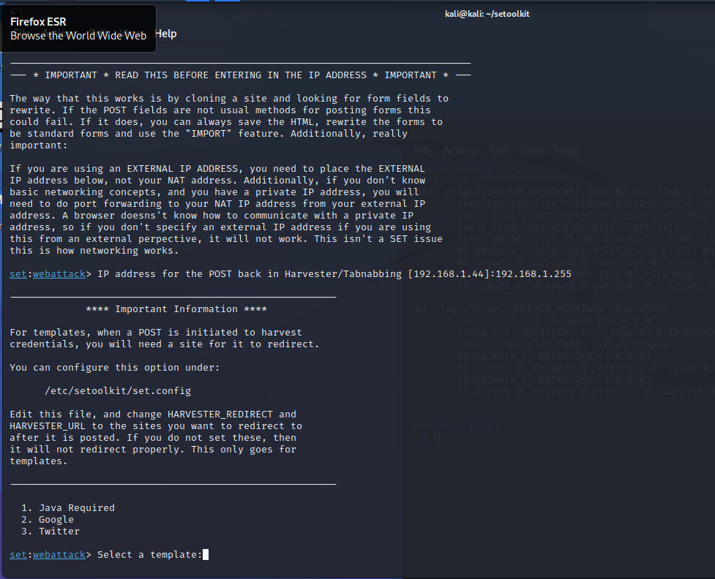

**select a template 2**

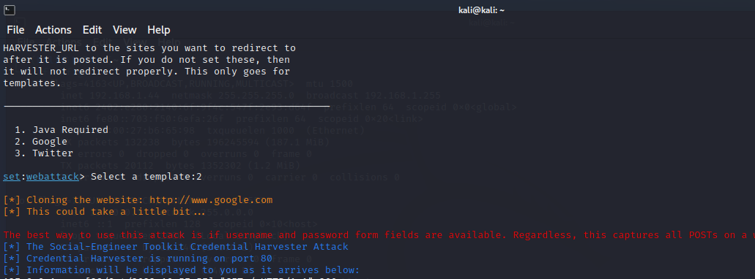

**Step 5: Now go to the browser in kali and type address 0.0.0.0:80 in the search bar and it will lead to the google sign in page.**

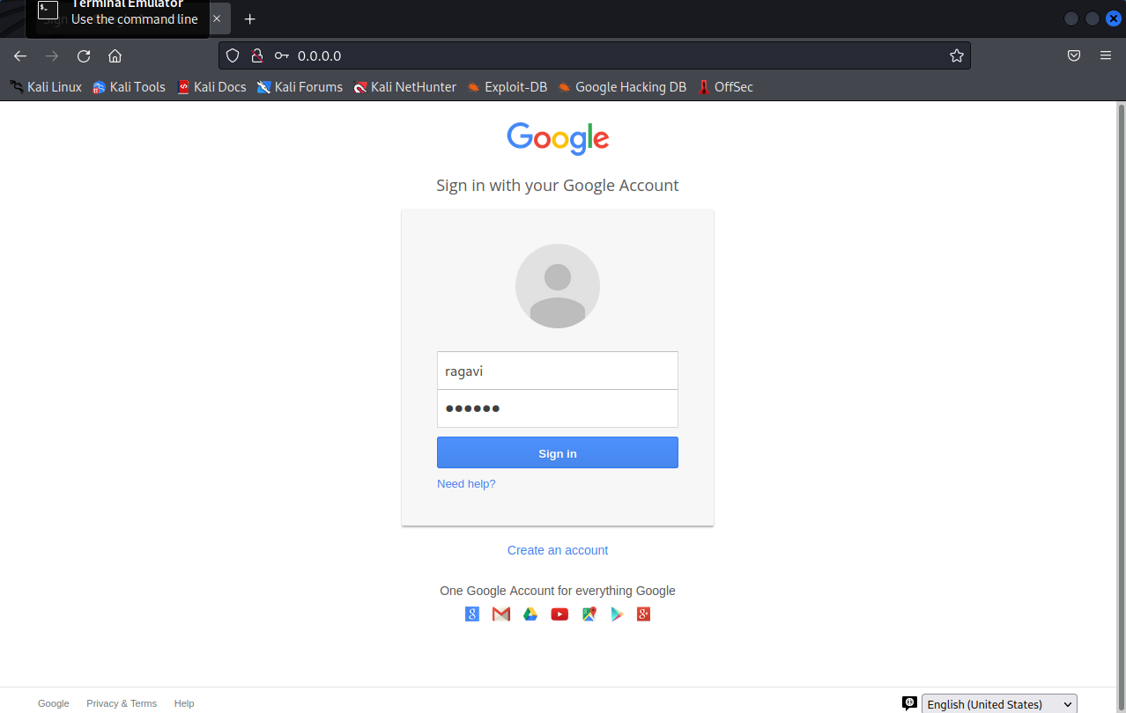

**Give some random username, password and sign in(which leads to google web page)**

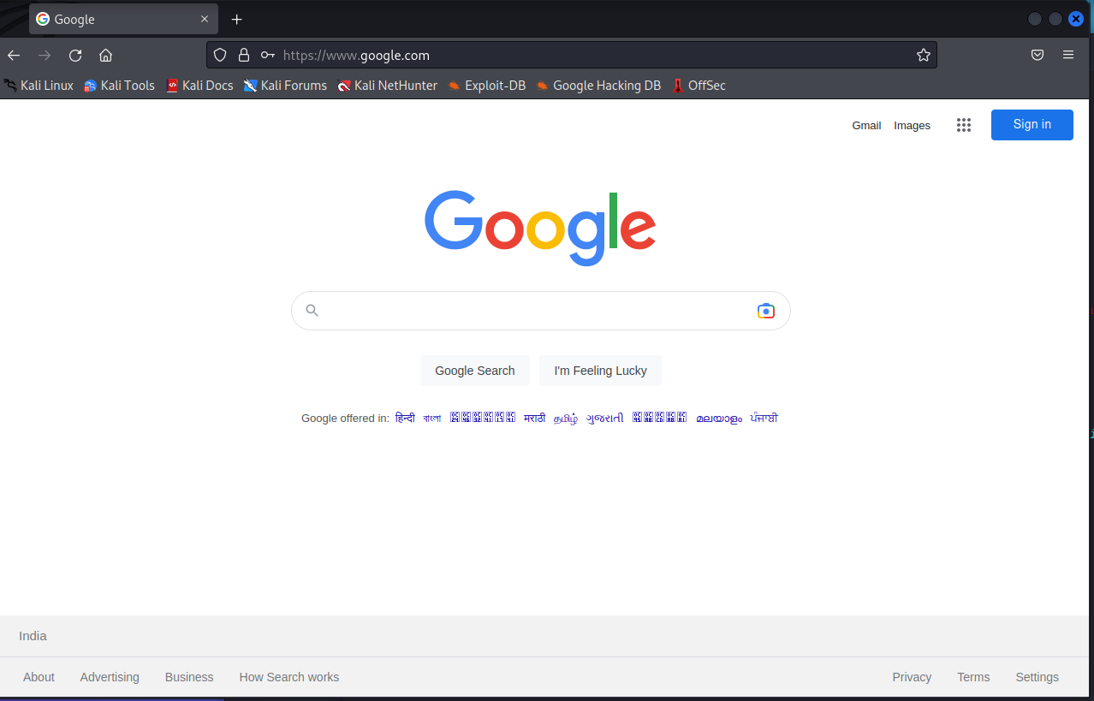

**Step 6: Now check terminal .**

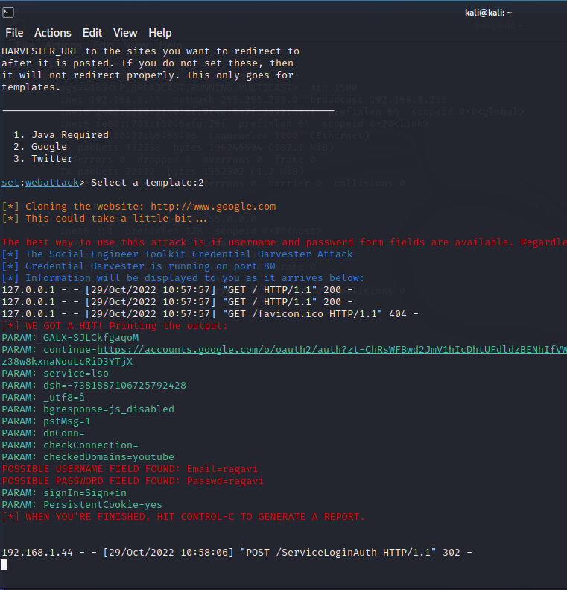

**2.Installing lazybox:**

**Step1:** git clone <https://github.com/arhaxor21/lazybox.git>

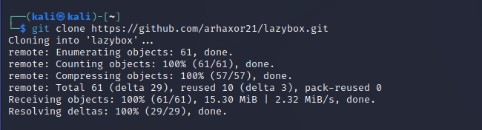

**Step 2:** cd lazybox/

**Step 3:** chmod +x lazybox.sh

**Step 4:** ./lazybox.sh

